What's high blood pressure?
Blood pressure is measured as two numbers, one over the other--for example, 120 over 80 millimeters of mercury (mm Hg). The systolic, or top, number reflects the pressure in the arteries when the heart is pumping. The diastolic, or bottom, number reflects the pressure between heartbeats. An elevation in either or both of those numbers constitutes hypertension. Optimal blood pressure is a systolic of less than 120 mm Hg and a diastolic of less than 80 mm Hg. Borderline high blood pressure is a systolic of 120 to 139 mm Hg and a diastolic of 80 to 89 mm Hg. And hypertension is a systolic of 140 or more mm Hg and a diastolic of 90 or more mm HG.

How to lower your blood pressure
Studies have conclusively shown that changes in lifestyle can reduce blood pressure substantially. Other research has clarified which medications work best for which people. Here is what you can do:

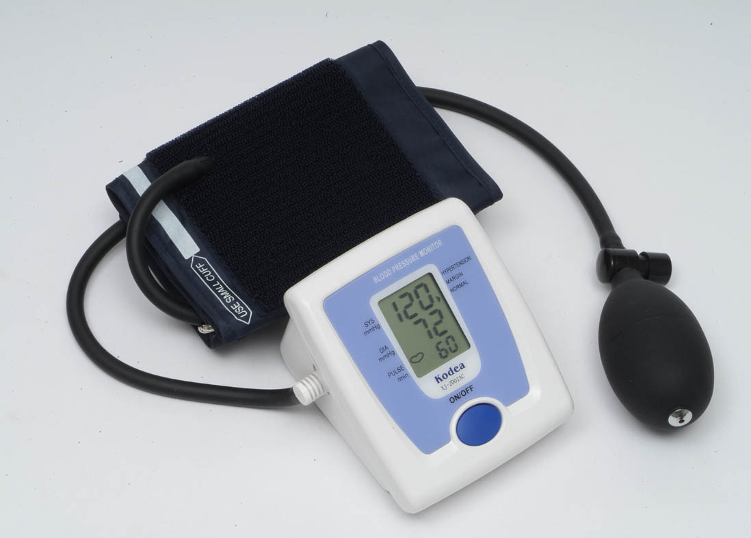

Getting started
For people with borderline or high blood pressure, home testing with the best blood pressure monitor is more important than ever. Recent research shows that an average of several readings over time provides the most reliable measurement. Home testing is essential for taking multiple readings and can actually be more accurate than the results you get at a doctor's office.
Our experts say that good candidates for at-home monitoring include:
- Seniors, whose blood pressure can vary.
- People who experience "white-coat hypertension," a spike in blood pressure when they are tested in a doctor's office or hospital; and
- People with diabetes, for whom tight blood pressure control is important.

How we tested
Our most recent tests of blood pressure monitors found many that are worth recommending.
Staff members assessed each model for comfort. Our testers compared the readings from those devices with readings taken with a mercury sphygmomanometer, often used in medical settings, to rate accuracy. A sensory panel evaluated how easy it was to use each monitor.

Check the fit
For arm models, make sure the blood pressure monitor you choose has a cuff that fits the circumference of your upper arm. Using a cuff that's the wrong size can result in a bad reading. Most models we tested have two cuffs or a cuff that adjusts to fit most people. Wrist models also adjust to fit most people.

Available features
An irregular-heartbeat detector checks for arrhythmias and other abnormalities. (We did not test those features.) A risk-category indicator tells you whether your blood pressure is in the high range. Multiple-user memory allows two or more users to save readings.

Ease of use
Make sure that the display on the monitor is easy to read and understand and that the buttons are big enough. The directions for applying the cuff and operating the monitor should be clear.
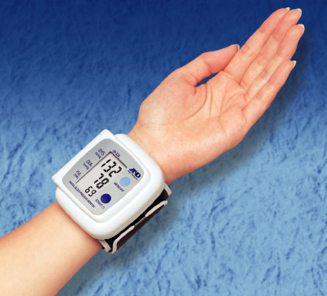

How to choose
Pick a top-scoring model that has features that will make testing easier for you, such as the ability of more than one user to store readings. Blood pressure monitors may be available at a discount, and some insurance plans may provide coverage for them. Check with your provider.

Accuracy
All of our (available to subscribers) were rated Excellent for accuracy.

Types

Automatic arm monitors
This type automatically inflates the cuff and displays the readings.

Wrist monitors
These convenient monitors are fully automatic, but may be less accurate than arm monitors.

How to check your blood pressure
Most people with hypertension should use a home monitor regularly. So should many people with prehypertension--particularly if they have other risk factors for heart disease. In general, you should check pressure at least twice a week at about the same time of day, and as often as twice a day if the hypertension isn't well controlled or if the treatment has changed. Here is how to get the most accurate results:
- Wait at least a half-hour after eating, drinking beverages with caffeine, smoking, or exercising before you test.
- Remove clothing or jewelry that interferes with placement of the cuff. If necessary, empty your bladder before testing.
- Sit in a comfortable chair with a back for support, and relax for at least 5 minutes before testing. Keep your feet flat on the floor. Don't talk, move, or cross your legs.
- With an arm monitor, adjust the cuff as directed by the product's manufacturer. The monitor's instructions should explain the proper positioning.
- Rest your arm on a table so that the cuff is at the same height as your heart. For wrist monitors, instructions normally direct you to place your wrist at the level of your heart.
- Do your initial tests on both arms. If the readings differ by more than a few points, check with your physician. If not, just use the more comfortable side.
- Take two readings about 1 or 2 minutes apart. Typically, the second reading will be lower. If the results differ by more than 5 points, take a third reading and average the results. Some automatic monitors will average three closely spaced readings automatically.

Blood glucose meters
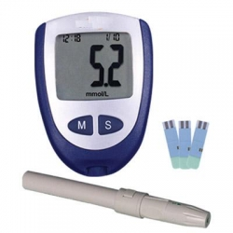
Today's blood glucose meters are smaller, faster, and come with more features than ever before. They're also more accurate than blood glucose meters of years past.
Controlling blood glucose is key to managing diabetes and preventing complications. Test results help patients make adjustments to their diet, exercise routine, and DEABETES plan, which can help lower the risk of seizures, blindness, kidney disease, and nerve damage.

Automatic coding
Blood glucose meters need to be calibrated to each batch of test strips. Some require you to enter a code or scan it with a smart phone, and if you do it incorrectly you could get inaccurate results. Others use a removable code chip to calibrate the meter to each batch of strips.

Data storage
The most convenient blood glucose meters store at least 360 test results. Some also track the average of your readings over seven, 14, or 30 days to give you a view of your overall blood sugar control. If you check your blood glucose frequently, consider a model with lots of memory.

Test time
The difference of a few seconds might not seem like much, but when you're using a meter three to five times a day, a longer test time can be a nuisance. Our panelists found that 5 seconds or less was desirable.

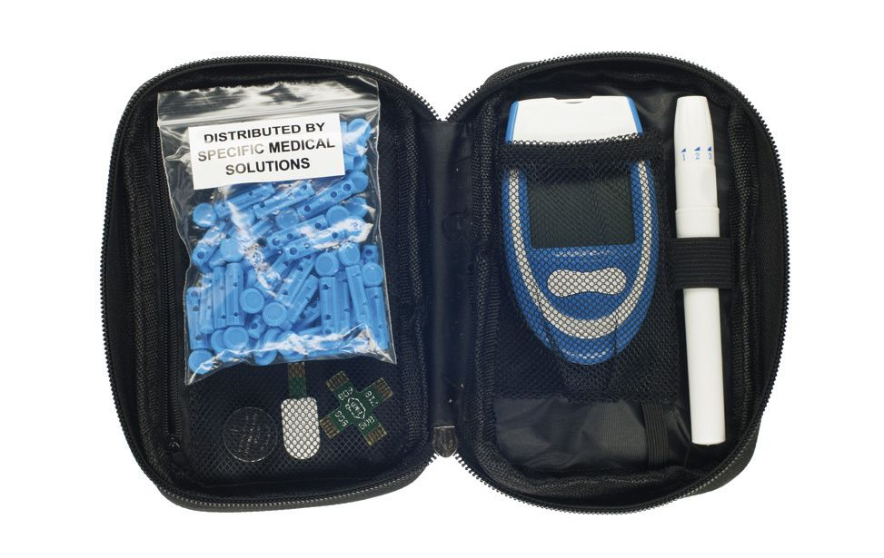

Test from your fingertip if you think your glucose is low
Some machines allow you to test blood from other sites, such as the forearm, but those aren't as accurate when your blood glucose levels are changing rapidly.

Wash your hands
Use soap and warm water and towel dry vigorously. Even a little sugar on your skin from food can throw off your results, as can dirt. The warm water and the brisk action of drying increases blood flow to your fingertips. Snapping your fingers can help as well.

Brace your finger
Holding it against a solid surface makes it less likely you'll pull away as the needle strikes.

Don't squeeze your finger
That usually leads to a poor finger prick and can result in errors.

Nebulisers
A nebuliser is a machine that converts liquid medication into a fine mist that can then be inhaled. They used to be used by many people to take their asthma medications, but these days are much less common as we have easier, faster and less expensive ways to take the medications.
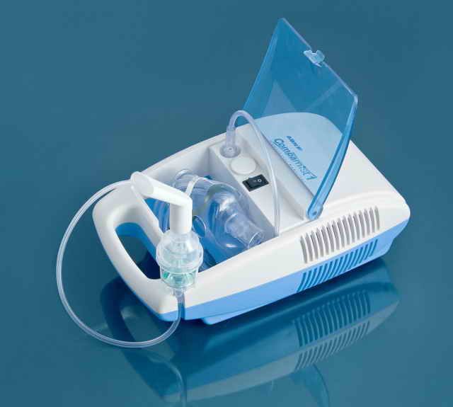

What does it do?
A nebuliser pushes compressed air through liquid medication, which makes it a mist. This is then inhaled through either a face mask or a mouthpiece. A standard dose of medication takes 5-10 minutes to be inhaled. Several different types of medication can be taken through a nebuliser, including relievers and preventers. In some cases, oxygen is used in the nebuliser, but only if the person’s oxygen levels are low.

Who should use a nebuliser?
Most people with asthma don’t need a nebuliser. It takes a lot more care to maintain the equipment, more time to take the medication, and the medication is much more expensive in liquid form. However, there are some situations where a nebuliser is still used:
  - If someone is really struggling to breathe in hospital or in an ambulance
  - If someone can’t use inhalers because they get confused, or have problems with their hands
  - For people who have a severe respiratory disease
  - For people who have lots of mucus and need the extra moisture in the nebulised treatment to help them clear out the mucus

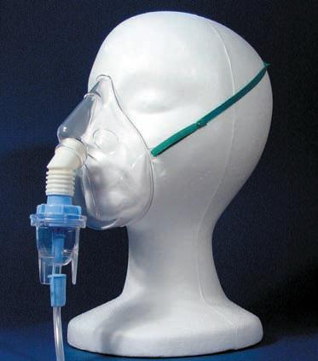

Aren’t nebulisers better than inhalers?
No. Taking the same dose of medication properly using a puffer with a spacer is at least as effective as taking it through a nebuliser, even when you are having anasthma attack. You can take the reliever medication faster and in a lower dose with a puffer and spacer, as it is delivered more effectively than through a nebuliser. One research study showed that children actually spent longer in the emergency department when they received reliever medication via a nebuliser rather than a spacer.

How to use a nebulizer

Because you have asthma, COPD, or another lung disease, your doctor has prescribed medicine that you need to take using a nebulizer. A nebulizer is a small machine that turns liquid medicine into a mist. You sit with the machine and breathe in through a connected mouthpiece. Medicine goes into your lungs as you take slow, deep breaths for 10 to 15 minutes. It is easy and pleasant to breathe the medicine into your lungs this way.
If you have asthma, you may not need to use a nebulizer. You may use an inhaler instead, which is usually just as effective. But a nebulizer can deliver medicine with less effort than an inhaler. You and your doctor can decide if a nebulizer is the best way to get the medicine you need. The choice of device may be based on whether you find a nebulizer easier to use and what type of medicine you take.
Most nebulizers are small, so they are easy to transport. Most nebulizers also work by using air compressors. A different kind, called an ultrasonic nebulizer, uses sound vibrations. This kind of nebulizer is quieter, but costs more money.
Take the time to keep your nebulizer clean so that it continues to work properly.
The basic steps to set up and use your nebulizer are as follows:
- Connect the hose to an air compressor.
- Fill the medicine cup with your prescription. To avoid spills, close the medicine cup tightly and always hold the mouthpiece straight up and down.
- Attach the hose and mouthpiece to the medicine cup.
- Place the mouthpiece in your mouth. Keep your lips firm around the mouthpiece so that all of the medicine goes into your lungs.
- Breathe through your mouth until all the medicine is used. This takes 10 to 15 minutes. If needed, use a nose clip so that you breathe only through your mouth. Small children usually do better if they wear a mask.
- Turn off the machine when done.
- Wash the medicine cup and mouthpiece with water and air dry until your next treatment.

